LAB 09
I2C Communication



Spring 2026
Embedded Systems Lab

Submitted By: Naveed Ahmad
Registration No: 22PWCSE2165
Class Section: B

Submitted to:

Engr. Muhammad Shahzad

June 25, 2026

Department of Computer Systems Engineering
University of Engineering and Technology

LAB 09
I2C COMMUNICATION (inter-integrated service)
I2C is a simple, low-speed, two-wire serial communication protocol used to connect multiple microcontrollers, sensors, displays, memory chips, and other peripherals on the same circuit board. Think of it as a bus where all devices share the same two wires.

The Two Essential Wires
Wire Name | Purpose
SDA (Serial Data Line) | Carries the actual data being sent (bi-directional).
SCL (Serial Clock Line) | Carries the clock signal generated by the master to synchronize data transfer.
Pull-up resistors are required on both wires (typically 4.7kΩ) to pull the lines to a logic high when no device is driving them.
How I2C Works (Master-Slave)
I2C uses a Master/Slave architecture.
Master: The device that controls the clock (SCL) and initiates all communication. (e.g., a microcontroller).
Slave: A peripheral device that waits for commands from the master. (e.g., temperature sensor)
Key feature: Every slave device has a unique 7-bit or 10-bit address. The master uses this address to talk to a specific slave.
Working: Every device has a unique address(like our reg.no), Send a start signal, broadcast the address, says read\write, the matching device responds, sends a stop signals

Pros vs. Cons
Pros | Cons
Only 2 wires (SDA, SCL) for many devices | Slower than SPI (typically 100kbps, 400kbps, or 3.4Mbps)
Multi-master & Multi-slave support | Requires pull-up resistors, limiting cable length
Simple addressing – no chip-select pins | Devices share the bus, so collisions are possible
ACK/NACK handshake for error checking | Power consumption higher than SPI due to pull-ups
Uses
Reading temperature/humidity sensors (e.g., BME280, AHT20)
Communicating with OLED/LCD displays (SSD1306)
Interfacing with real-time clocks (DS3231)
Reading EEPROM memory chips (24LCxx)
Connecting multiple Arduinos or micro:bits

HALF-DUPLEX COMMUNICATION

TASK 01:
- Scan I2C bus (find connected device). write a program that checks all 7-bit I2C adresses (0-127)
- For each address .>send start, >send address ,>check for ACK
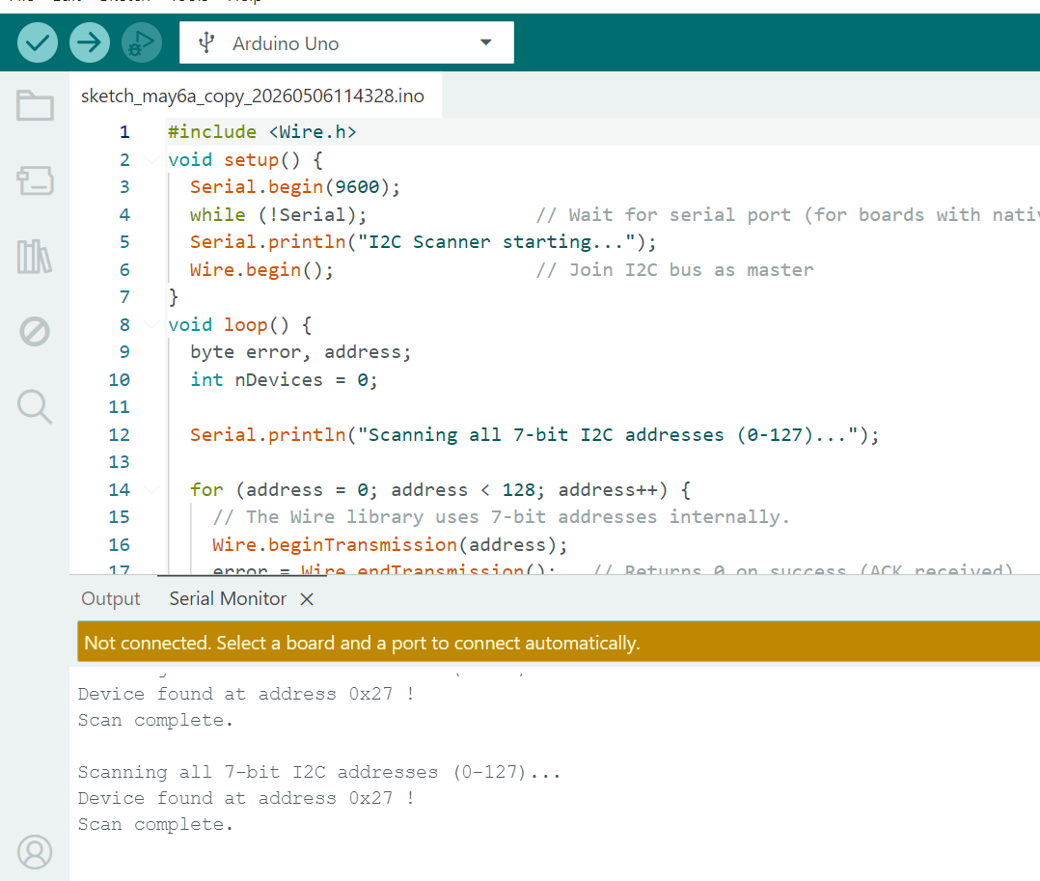

TASK 2
- Master writes data to slave 2x Arduino

MASTER WRITES
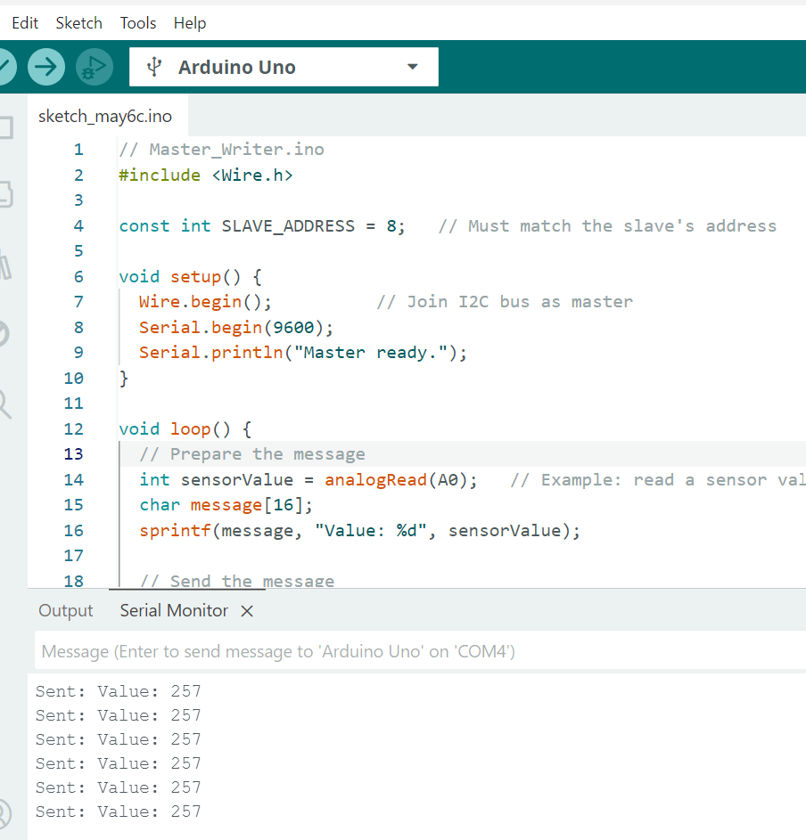

SLAVE RECEIVES
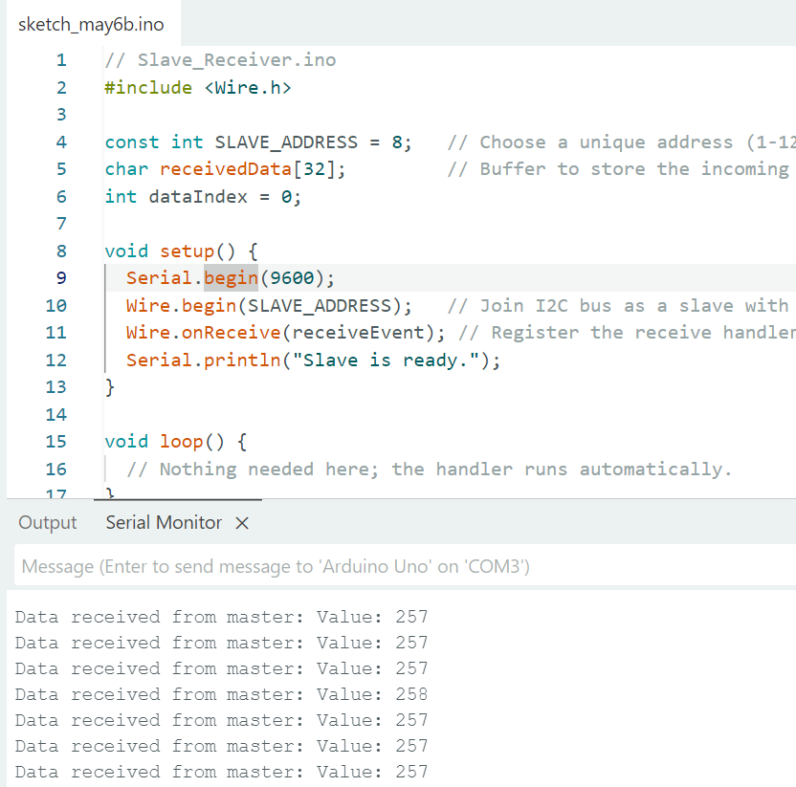

TASK 03:
Master reads data from slave

Master Reads :
:
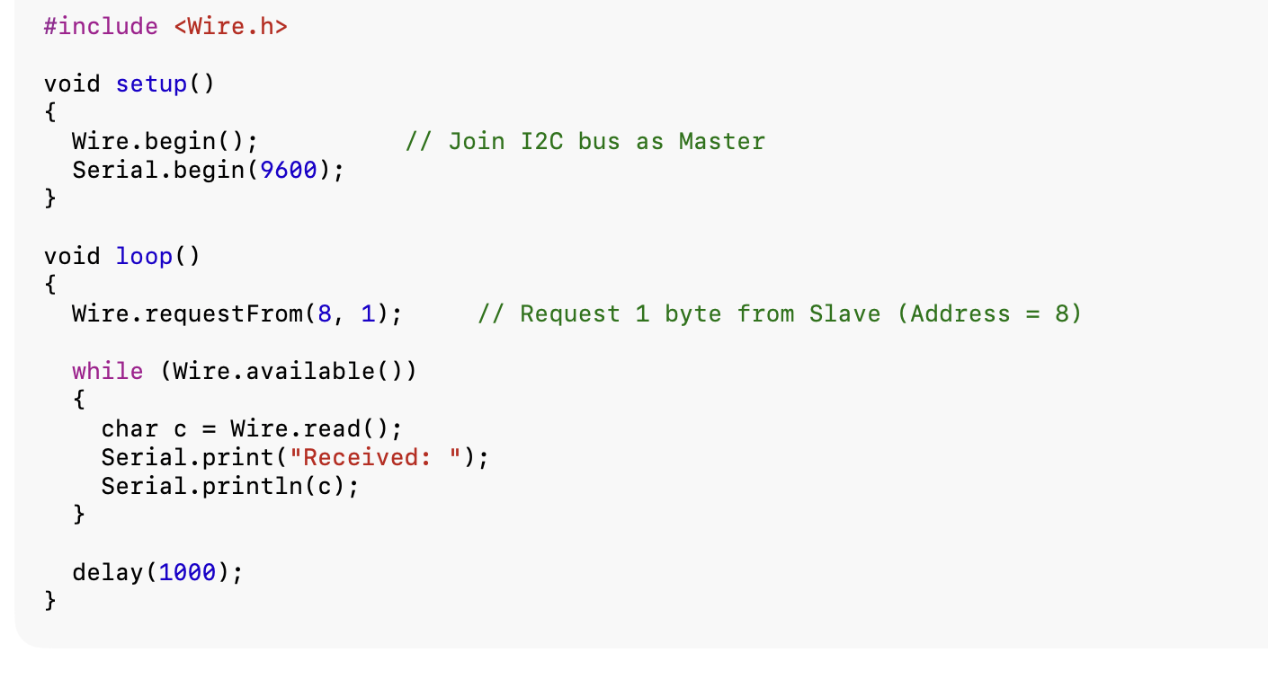
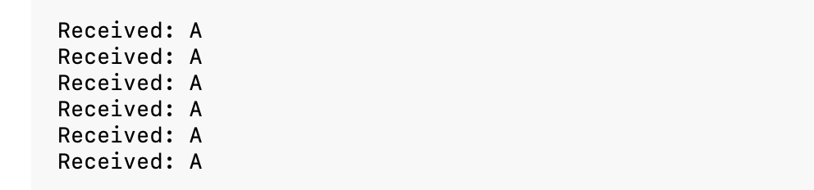

Slave Write:
